东华学报
2025年第42卷第4期
──────────────────────────────
本期责编: 编辑部 | 2025年11月24日

1. 细菌纤维素 / 透明质酸口腔速溶膜的制备及性能
吴晓艳, 宋炜, 陈爽, 肖茹
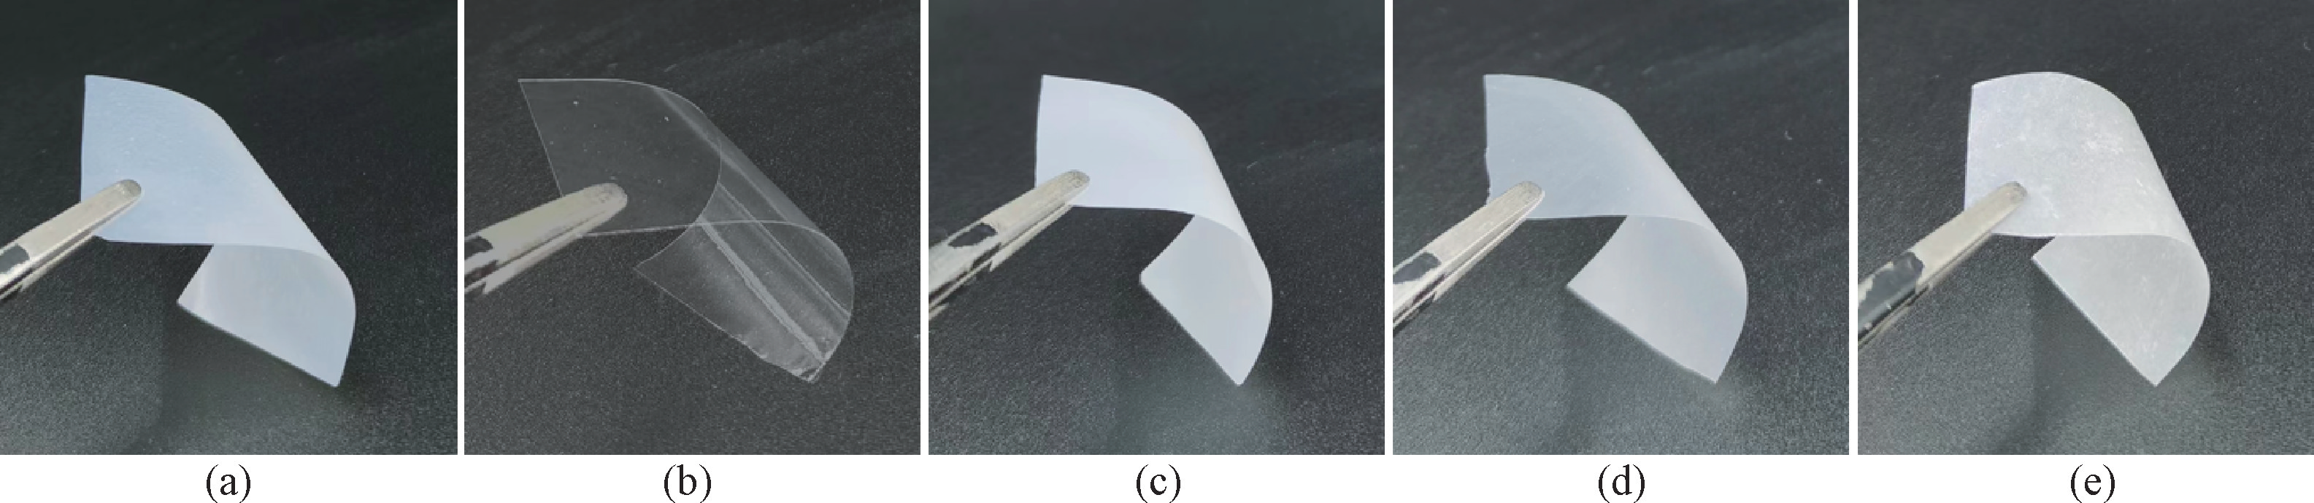
1. Preparation and Properties of Bacterial Cellulose / Hyaluronic Acid Oral Disintegrating Films
WU Xiaoyan, SONG Wei, CHEN Shuang, XIAO Ru
DOI: 10.19884/j.1672-5220.202404007
Citation: WU X O, SONG W, CHEN S, et al.. Preparation and Properties of Bacterial Cellulose / Hyaluronic Acid Oral Disintegrating Films. [J]. Journal of Donghua University (English Edition), 2025, 42(4), : 339-347.
────────────────────
作者说链接/OSID


2. 基于四丁基四氟硼酸铵修饰的导电炭黑开发头孢羟氨苄抗生素电化学传感器
朱宗贤, 张煊
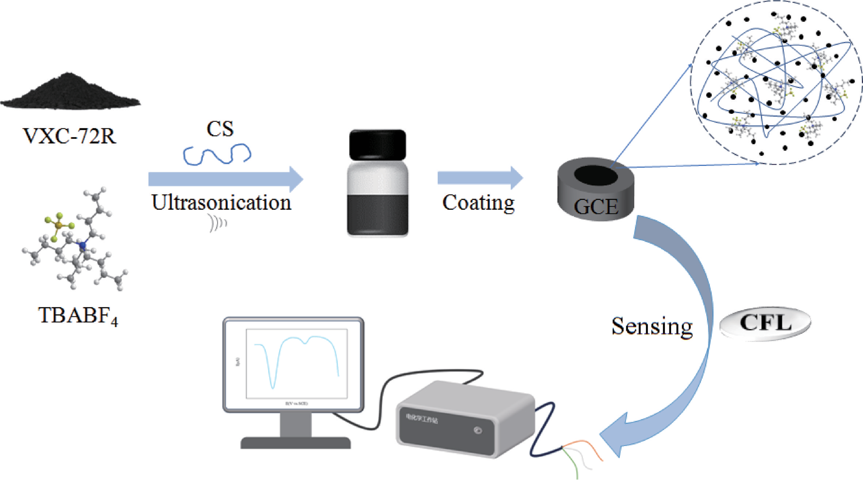
2. Development of Electrochemical Sensor for Cefadroxil Antibiotic Based on Conductive Carbon Black Decorated with Tetrabutylammonium Tetrafluoroborate
ZHU Zongxian, ZHANG Xuan
DOI: 10.19884/j.1672-5220.202406006
Citation: ZHU Z X, ZHANG X. Development of Electrochemical Sensor for Cefadroxil Antibiotic Based on Conductive Carbon Black Decorated with Tetrabutylammonium Tetrafluoroborate. [J]. Journal of Donghua University (English Edition), 2025, 42(4), : 348-357.
────────────────────
作者说链接/OSID


──────────────────────────────
感谢您的阅读！欢迎引用本文内容
© 2025 东华大学学报 版权所有

